HỌ TÊN : NGUYỄN XUÂN TRỰC
MSSV : 1513804
==================o0o==================

1) Select the first ICMP Echo Request message sent by your computer, and expand the Internet Protocol part of the packet in the packet details window.
SOLUTION
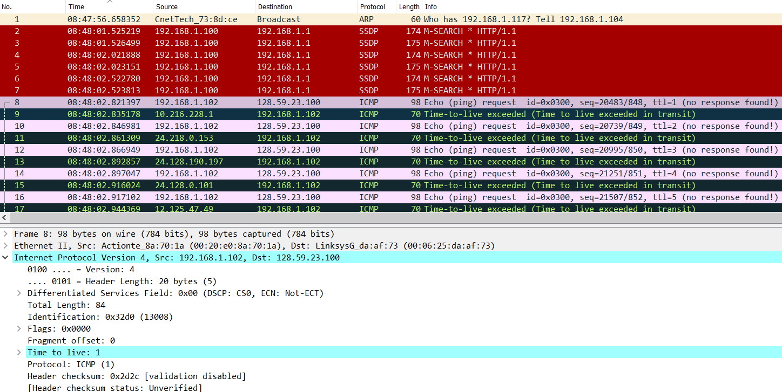
According to the figure 1, the IP address of my computer is 192.168.1.102

2) Within the IP packet header, what is the value in the upper layer protocol field?
SOLUTION
According to the figure 1, within the IP packet header, the value in the upper layer protocol field is ICMP (1).

3) How many bytes are in the IP header? How many bytes are in the payload of the IP datagram? Explain how you determined the number of payload bytes.
SOLUTION
According to the figure 1, the header length is 20 bytes and the total length is 84 bytes. Therefore, the payload of the IP datagram should be 64 bytes (84 bytes – 20 bytes).

4) Has this IP datagram been fragmented? Explain how you determined whether or not the datagram has been fragmented.
SOLUTION
According to the figure 1, under flags section, the more fragments bit = 0, so the data is not fragmented.

5) Which fields in the IP datagram always change from one datagram to the next within this series of ICMP messages sent by your computer?
SOLUTION
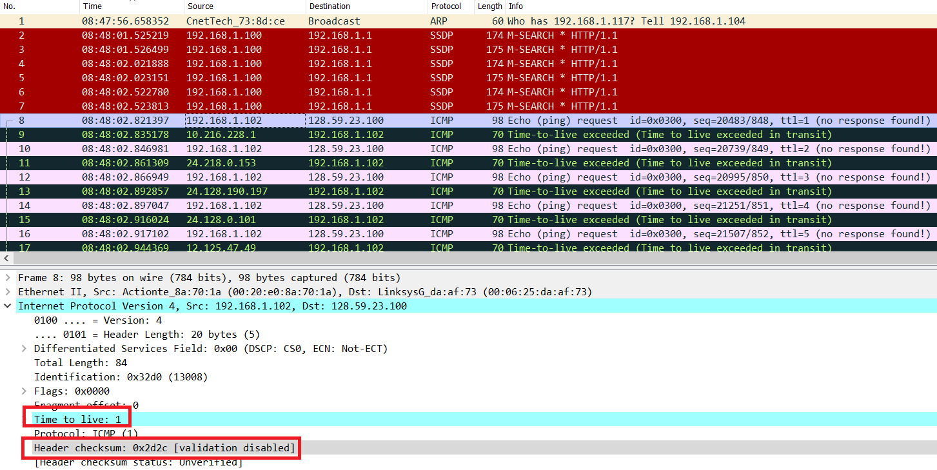
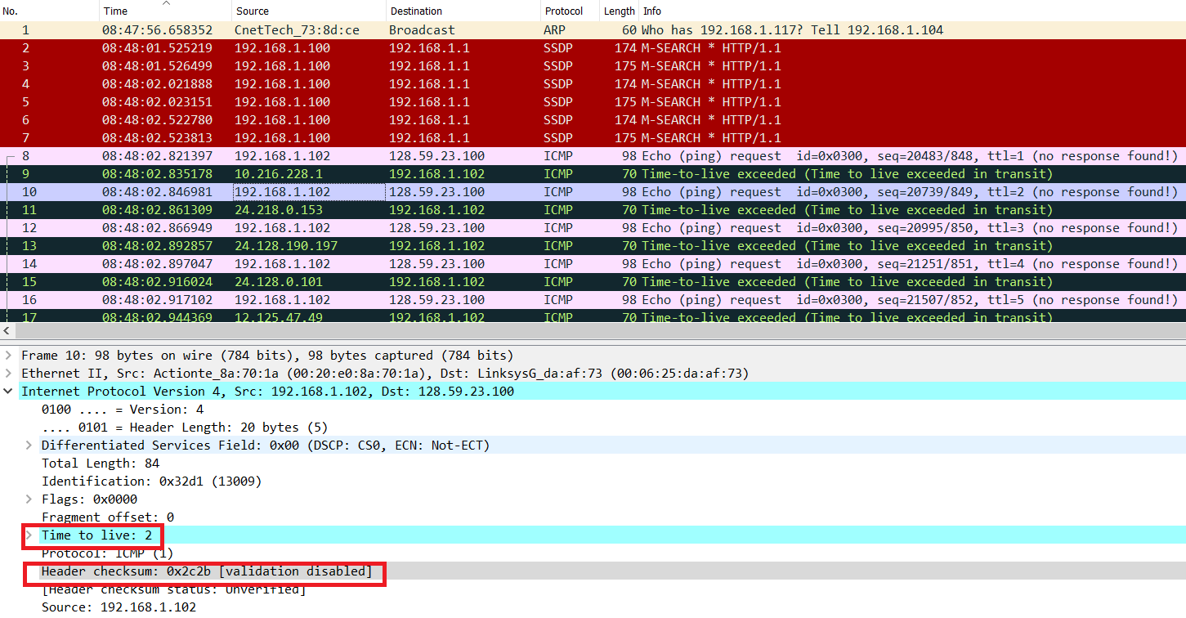
According to above two screenshots, identification, Time to live and Header checksum always change.

6) Which fields stay constant? Which of the fields must stay constant? Which fields must change? Why?
SOLUTION
The fields that stay constant are: Version (since we are using IPv4), header length (since these are UDP packets), source IP (since all packets are sent from my computer), destination IP (since we are sending to the same host), Differentiated Services (since all packets are UDP), Upper Layer Protocol (since these are UDP packets)
The fields that must stay constant are: Version (since we are using IPv4), header length (since these are UDP packets), source IP (since all packets are sent from my computer), destination IP (since we are sending to the same host), Differentiated Services (since all packets are UDP), Upper Layer Protocol (since these are UDP packets)
The fields that must change are: Identification (IP packets have different ids), Time to live (traceroute increments each packet), Header checksum (since header changes)

7) Describe the pattern you see in the values in the Identification field of the IP datagram
8) What is the value in the Identification field and the TTL field?
SOLUTION
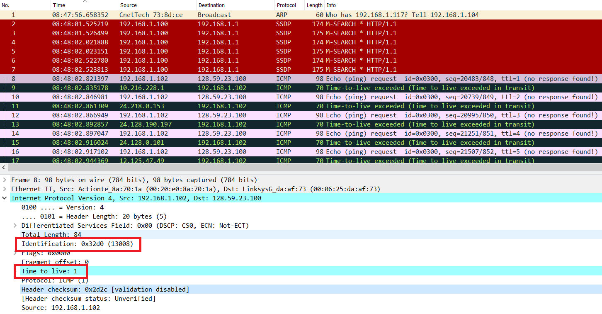
According to above screenshot, Identification: 13008, TTL: 1
9) Do these values remain unchanged for all of the ICMP TTL-exceeded replies sent to your computer by the nearest (first hop) router? Why?
SOLUTION
The values of identification field changes for all the ICMP TTL‐exceeded replies since the identification field is a unique value. If two or more IP datagrams have the same identification value, then it means that these IP datagrams are fragments of a single large IP datagram.
The TTL field was unchanged since the TTL for the nearest router is always the same (Windown, TTL 1).

10) Find the first ICMP Echo Request message that was sent by your computer after you changed the Packet Size in pingplotter to be 2000. Has that message been fragmented across more than one IP datagram?
SOLUTION

